CUSTOMER ↔ ZKONG API integration
Basic procedures
- Get ERP public key
  - Endpoint: GET /zk/user/getErpPublicKey
  - Purpose: fetch the RSA public key used to encrypt the password before login.
- Login
  - Endpoint: POST /zk/user/login
  - Purpose: log in with:
    - Account (plaintext)
    - password = RSA-encrypted password
    - loginType = 3
  - Result: returns a token plus user / merchant / store info. If business APIs later return 401, log in again and get a new token.
- Use token for subsequent requests
  - Header: Authorization: <token>
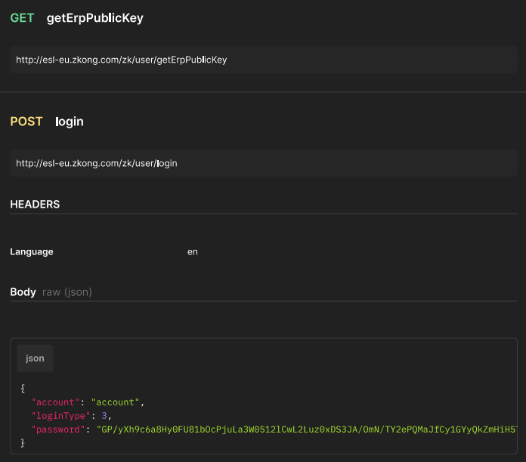
  - All requests require authentication and the token must be sent in the Authorization header.

Main product sync endpoint
- Import / update products
  - Endpoint: POST /zk/item/batchImportItem
  - Purpose: used to import products into ZKONG system, and also to update/overwrite existing product data, including price fields, for the same barcode.
  - This is the main endpoint used for product and price synchronization.
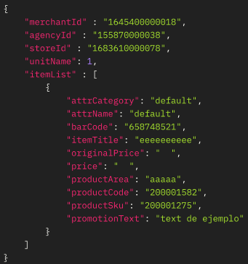

Important notes about batchImportItem
- Limit
  - itemList supports up to 20,000 items per request.
- Key required fields
  - merchantId
  - agencyId
  - itemList
  - inside each item, important required fields include:
    - barCode
    - attrCategory
    - attrName
- Price fields it can update
  - originalPrice
  - price
  - memberPrice
- How overwrite works
  - When CUSTOMER sends the same product barcode again, ZKONG uses the incoming product data as the latest version.
  - There is also an emptyNeedDelete query parameter:
    - 0 = keep the original value if the new field is empty
    - 1 = overwrite the existing value with empty
  - Default is 1.
- Store handling
  - If storeId is empty, data goes to the merchant-level product list.
  - If storeId is provided, data is imported only into that store’s products.
  - ZKONG also supports externalStoreId with:
    - useExternalStoreId=1
    - externalStoreId=...
  - External store IDs must already exist in ZKONG first.

Useful follow-up endpoints
- Check whether a product exists / read current data
  - Endpoint: POST /zk/item/getItemByBarCodeAndExternalStoreId
  - Use this to verify that a product from CUSTOMER exists in ZKONG and see current stored values.
- List products with paging
  - Endpoint: POST /zk/erp/item/list
  - Use this for paged store product queries.
- Check import logs
  - Endpoint: POST /zk/integratedLog/integratedLogPage
  - Use this to review product import results, success / partial success / failures, and track by requestId.

Simple recommended CUSTOMER flow
- CUSTOMER calls GET /zk/user/getErpPublicKey
- CUSTOMER encrypts password with that RSA key
- CUSTOMER calls POST /zk/user/login
- CUSTOMER stores the returned token
- CUSTOMER sends product and price updates through POST /zk/item/batchImportItem
- CUSTOMER checks results via:
  - POST /zk/item/getItemByBarCodeAndExternalStoreId
  - POST /zk/integratedLog/integratedLogPage

